Main Contact/Organiser Details

Your Name
Email Address
Mobile Number
Name of host organisation
(if applicable)

The information below will be added to the Irish Dementia Cafe Network’s website

Name of dementia café
Location/address of café
Name and public contact information for café organiser (email/phone number)

Time and date that café is held
(e.g. second Monday every month)
Is this café in-person or online/virtual?
Website and/or social media details
(if applicable)
Launch date of first meeting, if has not yet occurred.

Irish Dementia Café Network Four Principles

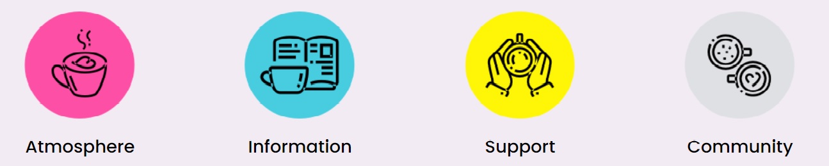

How We Support You!

As a member of the Irish Dementia Cafe Network:
- The details of your dementia cafe will be published on the Irish Dementia Cafe Network website, helping with the promotion of your cafe
- We will promote your café on our social media if provided with details in advance
- You will be given opportunities to meet other dementia cafe teams at our free Learning and Networking events run each year – a great way to feel part of something BIG!
- You will have access to the café network’s pool of tools and resources
- We will endeavour to support you with advice to the best of our ability and answer questions you may have

Data protection
The café details which you have provided on this form will be published on the Irish Dementia Cafe Network website. The member contact details you have given will be used only with regard to your membership of the Irish Dementia Cafe Network, and not shared with any third party.
If your dementia café ceases to meet/changes location/needs updating, please notify the Irish Dementia Cafe Network so that the entry on the network website can be amended or be removed.
Email: cafenetwork@engagingdementia.ie
The project is managed by Engaging Dementia, with input from an Expert Advisory Panel, and in consultation with member dementia cafes nationwide. Website: www.dementiacafe.ie
Engaging Dementia (formerly Sonas apc) is a registered charity. Registered Charity Number 20033439 CHY 11839. Address: Mounttown Community Facility, Meadowlands, Fitzgerald Park, Lower Mounttown Road, Dun Laoghaire, Co Dublin, A96 KR65. Tel: 01 260 8138 Web: www.engagingdementia.ie

