**Main Contact/Organiser Details**

|  |  |
| --- | --- |
| Name of Dementia Café |  |
| Your Name |  |
| Email Address |  |
| Mobile Number |  |
| Name of host organisation (if applicable) |  |

**Steering Committee Details**

|  |  |  |
| --- | --- | --- |
| Names | Job title and organisation | Committee role |
|  |  |  |

**Note:**

Member Cafés are run by a voluntary steering committee of roughly 4 – 6 members, who support each other and work together to run the café in their community. Not all members need be present at every café as we understand this is a voluntary role, but active participation is required. We advise on a minimum of 4 members to ensure continuity in the running of the café in the instance that someone might need to leave the committee and be replaced.

The committee must include:

* A health/social care professional involved with services for people living with dementia and their carers. The inclusion of this person is for the café to know best practise of service provision for those living with dementia.
* An expert by experience. This could be a family carer or someone living with dementia. This role must be filled within one year of setting up the café as we feel that their voice is invaluable in managing the running these events.

Examples of people who might be on the steering committee are:

* Local dementia adviser
* An occupational therapist
* Volunteer from a local community group
* Student learning in the field of nursing or healthcare
* Anyone who is interested in being a part of supporting a dementia inclusive community

**Please provide information on your café**

**The information below will be added to the Irish Dementia Cafe Network’s website**

|  |  |
| --- | --- |
| Name of café |  |
| Location/address of café |  |
| Name and public contact information for café host/organiser (email/phone number) |  |
| Time and date that café is held (e.g. second Monday every month) |  |
| Is this café in-person or online/virtual? |  |
| Website and/or social media details (if applicable) |  |
| Launch date of first meeting, if not yet occurred. |  |

**Irish Dementia Café Network Four Principles:**

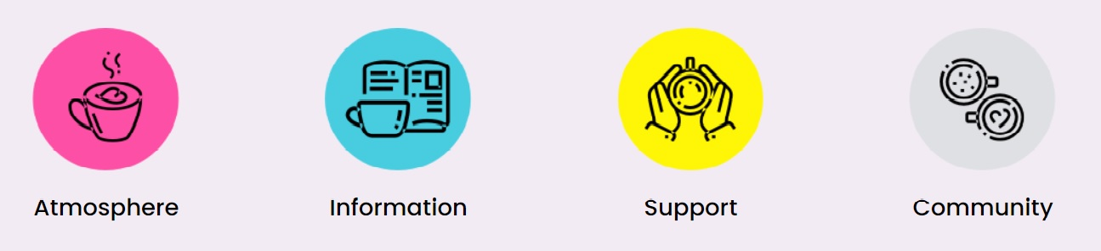

**Note:**

By completing this form and sending it to the Irish Dementia Cafe Network, you are confirming that your dementia cafe is:

* Aligned with the principles of Atmosphere, Information, Support, Community.
* Welcoming of people living with dementia and their families
* Run by a voluntary steering committee as detailed above
* Follows the dementia cafe network guidelines.
* You will indicate your dementia cafe’s membership of the Irish Dementia Cafe Network by including the *Member of the Irish Dementia Cafe Network* logo on promotional materials.
* You will support the measurement of impact of dementia cafes by providing the cafe network with general information about your cafe at the end of each year, when possible.

**How We Support You!**

As a member of the Irish Dementia Cafe Network:

* The details of your dementia cafe will be published on the Irish Dementia Cafe Network website, helping with the promotion of your cafe
* We will promote your café on our social media if provided with details in advance
* You will be given opportunities to meet other dementia cafe teams at our free Learning and Networking events run each year – a great way to feel part of something BIG!
* You will have access to the café network’s pool of tools and resources
* We will endeavour to support you with advice to the best of our ability and answer questions you may have

**Data protection**

The café details which you have provided on this form will be published on the Irish Dementia Cafe Network website. The member contact details you have given will be used only with regard to your membership of the Irish Dementia Cafe Network, and not shared with any third party.

If your dementia café ceases to meet/changes location/needs updating, please notify the Irish Dementia Cafe Network so that the entry on the network website can be amended or be removed. Email: [cafenetwork@engagingdementia.ie](mailto:cafenetwork@engagingdementia.ie)

I understand and agree with the above.

**Signed:**

**Date:**

Engaging Dementia was commissioned by the HSE National Dementia Office to develop the Irish Dementia Cafe Network in 2019. The project is managed by Engaging Dementia, with input from an Expert Advisory Panel, and in consultation with member dementia cafes nationwide.

Phone: 085 2691025 Email: cafenetwork@engagingdementia.ie

Website: [www.dementiacafe.ie](http://www.dementiacafe.ie)

Engaging Dementia (formerly Sonas apc) is a registered charity. Registered Charity Number 20033439  CHY 11839. Address: Mounttown Community Facility, Meadowlands, Fitzgerald Park, Lower Mounttown Road, Dun Laoghaire, Co Dublin, A96 KR65. Tel: 01 260 8138 Web: www.engagingdementia.ie